**빨간 글씨 : 추가한 부분**

**빨간 공백 : 띄어쓰기 한 부분**

**빨간 취소선 : 글자 지운 부분 (괄호로 ‘00지운거’ 써놓음)**

**노란색 형광 : grammarly에서는 추가하라고 나오는데 확실치가 않은부분**

**파란색 형광 : grammarly에서 삭제 추천**

**초록색 형광 : grammarly에서 변경 추천**

Title

Feasibility of Networking Technology for Smart Farms: LoRa vs APRS

Abstract

Smart Farms and IoT (Internet of Things) have an inseparable relationship. Sensors, gateways, servers, databases, web-based applications, are all connected to smart farms. Hence, the decision of networking technology is very vital when running a smart farm. LoRa (Long Range) has been the most suggested candidate for smart farms. Theoretically, APRS (Automatic Packet Reporting System) can communicate far more distance than LoRa. However, there were no existing studies that implemented APRS in the smart farm IoT system. Therefore, this study tests and compares the distance coverage of LoRa and APRS networking technologies in an university’s agronomy center. The results were evident that LoRa is more feasible than using APRS in the smart farm IoT system.

Introduction

With the fourth industrial revolution and the advancement of IoT technology, ICT (Information and Communication Technologies) has been integrated into agriculture and increased not only the quantity and quality of products but also convenience for the farmers. In IoT-based smart farming, data from weather conditions, light, soil moisture, or crop’s growth progress is collected by IoT device sensors. With the data, farmers can monitor the field conditions from anywhere with smart devices. Also, irrigation systems are automated so that the water will be used more efficiently and the yields will be improved. In recent years, research on solutions to increase the performance and productivity of the smart farm while lowering the cost has become very popular. Previous studies like \cite{b1} show that the main technologies of IoT based smart farming are network technologies, security, and IoT agriculture applications.

To be more specific with the networks, there are numerous network technologies for wireless connection of the sensors and actuators for IoT. The network technologies focus on providing scalability, extended coverage, low cost, and energy efficiency for the end-user devices \cite{b2}. Since the IoT agricultural network helps to monitor agriculture data and facilitate the transmission and reception of agriculture data, it is one of the vital elements of IoT in agriculture \cite{b1}.

Although a lot of research focus on implementing an IoT system with a suitable communication network for smart farming, little attention has been given to comparing communication systems to decide the better network technology. Therefore, this study focuses on two network technologies, LoRa and APRS, for the smart farm IoT system. The objective of this paper is to question the feasibility of LoRa and APRS in the smart farm IoT system and to propose a better network technology that is more suitable for a smart farm. In this paper, we experiment the distance coverage of LoRa and APRS at an university’s agronomy center.

Related work

This section discusses the existing IoT communication protocols, explaining why we particularly chose LoRa and APRS for this study.

LoRa

As this study focuses on IoT devices for smart farms, protocol selection was made within Low-Power Wide Area Networks (LPWANs). Two main factors should be considered when developing smart farm IoT devices: 1) wide area coverage; 2) long battery life. Therefore, short-range communication protocols like Bluetooth or ZigBee are not likely used for IoT devices that require long-range communication and wide area coverage. LPWAN, on the other hand, provides long-range connections with low data transmission rates\cite{b10}. Hence, LPWAN should be used for low power IoT devices that transmit a small amount of data and require battery efficiency\cite{b11}. Smart farm IoT devices suite these descriptions, comparatively small data collected by sensors transmitted for long-range communication.

LoRa, NB-IoT, Sigfox, Weightless are some of the leading LPWAN technologies. This study specifically tests LoRa as it is known to provide long-range communication and long battery life on a low budget\cite{b12}. LoRa’s advantages are shown in many studies. Ji et al.\cite{b13} successfully transmitted image data using LoRa technology. Kodali et al.\cite{b14} implemented an irrigation system in a smart farm through a web interface.

APRS

Automatic Packet Reporting System (APRS), also known as ‘amateur radio’ or ‘ham radio’, was designed by Bob Bruninga about 25 years ago. APRS enables real-time information exchange between multiple nodes and the processed data are visualized on APRS-Internet Service (APRS-IS) websites as the APRS infrastructure\cite{b15,b16}. APRS is transmitted on a shared local VHF frequency, depending on the country. North America uses 144.39 MHz. Although APRS was designed for large local areas, easy digital repeating with callsigns allows fast global communications\cite{b17}. Due to these characteristics, APRS has been used for real-time tactical, emergent situations.

There are many attempts like Hajdarevic et al.\cite{b16} on building low-cost, low-energy APRS transceivers on microcontrollers or single-board computers such as Arduino and Raspberry Pi. Despite the increasing interest in building low-cost APRS transceivers and APRS' characteristics suitable for IoT devices, there was no research that solely used or tested APRS as an IoT communication protocol. This raised the question of why APRS is not applied in the IoT field. Therefore, this study ultimately aims to answer the question of the feasibility of APRS for long-range IoT device communications.

Approach

At first, we weren’t aware of the antenna’s characteristics, so the results were very different from our expectations. In order to minimize any errors, many attempts were made.

Both LoRa and APRS communication distance results were too short compared to theoretical results. After modifying LoRa’s transmitter and receiver code by LoRa’s TX power to 13, signal bandwidth to 125E3, and coding rate to 5 using LoRa Arduino API, the communication range results increased from 100m to 1km, as shown in Fig. 1.

<The change of LoRa’s distance coverage>

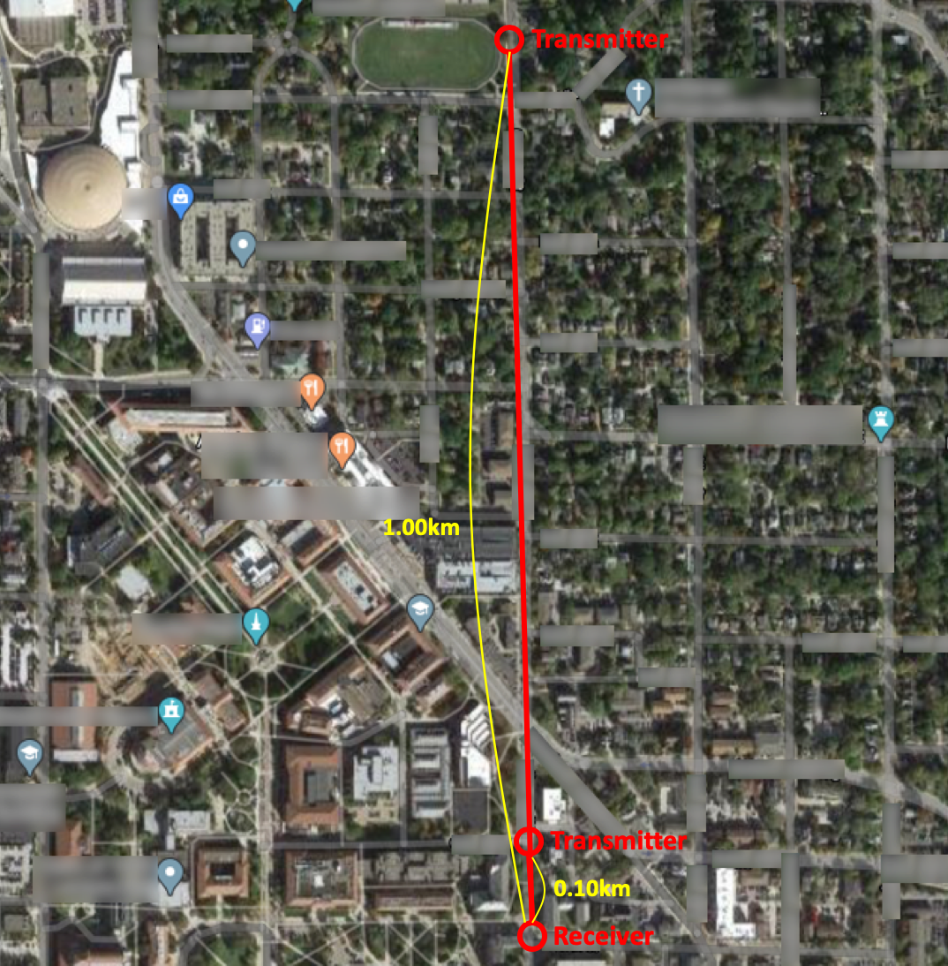

After realizing that there were problems with our APRS antenna, we tested the antenna’s ground condition, height, and whether the two antennas were in parallel. Since the antenna had a magnetized bottom, grounding was a crucial factor. Therefore, by attaching the antenna to a metal surface improved the performance. Also, in order to increase the communication distance, the antenna needed to be installed higher, so the placing of the receiver antenna was changed from the ground to 4.5meters above the surface. Moreover, to transmit radio waves efficiently, the antennas needed to be installed in the same directions parallelly. From these modifications, the communication distance increased from 50 m to 890m, as shown in Fig. 2. Since the test environment was an open space environment which was at most 890m the result could not be further. Due to the 10 m height difference between the transmitter and receiver antenna, the communication distance increased than the previous setting when there was no height difference. Based on these attempts, we recognized the features of the antenna and were able to conduct proper experiments later on while adjusting the parameters given above.

<The change of LoRa’s distance coverage>

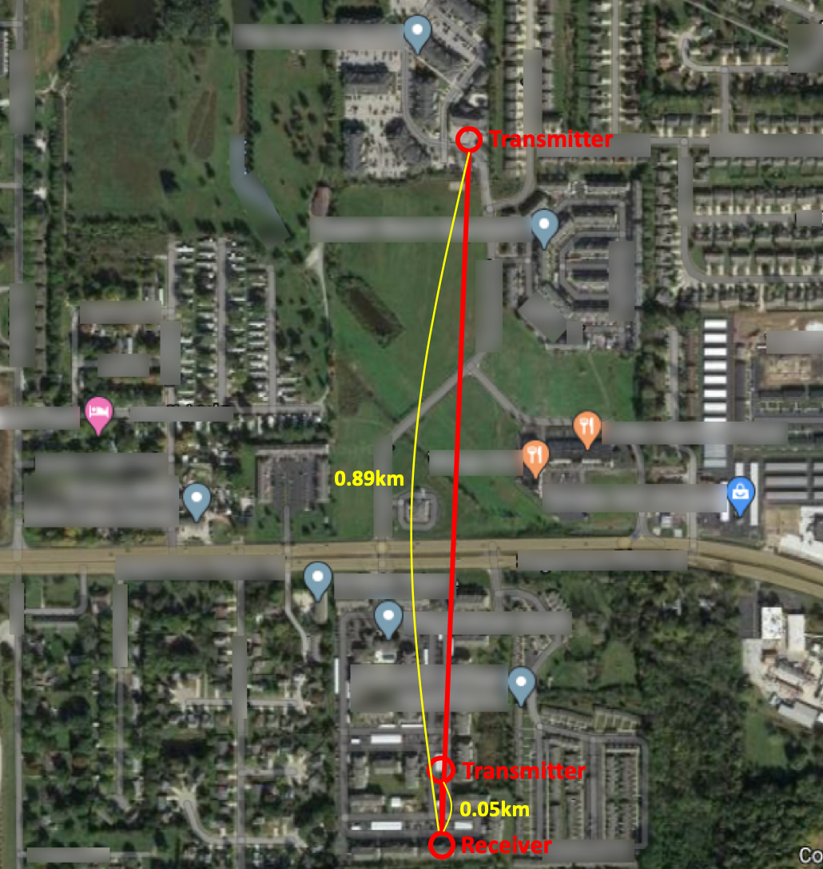

Also, since LoRa and APRS used different kinds of antennas, it was difficult to find respective antennas for both the transmitter and receiver with the same gain. Thus, we experimented by making the sum of the gain of LoRa's transmitter antenna and LoRa's transmission power as similar to the sum of the gain of APRS’s transmitter antenna and APRS’s transmission power. This allowed LoRa and APRS EIRP to be equal. We checked the transmission power of LoRa and APRS by using a spectrum analyzer. Since we measured the transmission power of the part which the antenna is connected to, this is the final output power that includes the cable and connector loss. This indicates the transmission power discussed later in the paper.

Results

For the feasibility test of LoRa and APRS, we have conducted several tests outside at the Purdue Agronomy Center for Research and Education. This section mentions the test environments, multiple test results, and result evaluation for the distance coverage comparison of LoRa and APRS.

Test Environment

The distance comparison tests between LoRa and APRS were conducted at an university’s agronomy center. The tests were conducted by placing the receiving antenna at the weather station of the Purdue Agronomy Center. The receiving antenna of LoRa and the receiving antenna of APRS were installed on the same bar but on different height. The receiving antenna of LoRa was 4.0 meters high from the ground, 6.4 meters high for APRS. Transmitters were on the move, checking if the data were properly received at the receiving end, the weather station. Both transmitters were carried in a car, and the antenna of APRS was securely attached to the roof of the car, while LoRa’s antenna was held at the same height as the transmitting antenna of APRS, 2.35 m. The location of the transmitting points were all saved on Google Maps, which was later used to calculate the distance from the weather station to the transmitter. To minimize radio interference during testing, LoRa and APRS were tested alternately. Also, cell phone calls were banned and at least 30 seconds of waiting time was ensured to prevent possible errors due to the movement of the transmitters. If the data were consecutively received, the transmitters were moved forward for further distance. If not, the transmitters moved back to shorten the distance. This process was repeated to find the last transmitting point where data were successfully transmitted. All of the following distance results were derived by calculating the distance between the weather station and the last transmitting point using Google Maps.

Tests

Table 1 shows the overall distance coverage results from each test while Table 1 and 2 shows the antenna specifications for LoRa and APRS.

1st test

The transmitter and receiver of LoRa consist of Arduino and LoRa Shield v1.4. The antenna gain for both transmitting and receiving ends are 2.14 dBi. Both antennas were held by hand on about 1 m above ground. The output power of the transmitter antenna measured by the spectrum analyzer was 16 dBm. Due to weather conditions, the receiver antenna was inside the weather station. The maximum distance coverage was 160 m.

<tables>

APRS used Arduino and HX1 transmitter while the antenna was connected using jumper cables. Software Defined Radio (SDR), powered by a laptop and an antenna was used as the receiver for APRS. The gain of the transmitter antenna for APRS was 2.14 dBi and the transmitting power was 15 dBm. For the receiver, the antenna gain was 6 dBi. At that time, the maximum distance was 1.3 km. Transmitting and receiving conditions were generally good, although some of the data were missed from time to time.

2nd test

LoRa changed both transmitter and receiver antenna. Previously, the antenna gain for both antennas was 2.14 dBi. With the new antennas, the transmitter antenna had 9 dBi gain and the receiver antenna had 6 dBi gain. The transmitter antenna was attached to the car roof at about 1.8 meters above the ground. With the new antenna specifications, LoRa was able to cover 4.2 km, successfully receiving data.

For APRS, the setup for both sides was the same as before, except for a transistor. A transistor was added to amplify the output power of the transmitter. While the transmitter antenna gain was identical to 2.14 dBi, the output power increased to 20 dBm by using the transistor. Two tests were conducted on this second test: 1) without transistor; 2) with the transistor. APRS covered 670 m without using the transistor, while it covered 700 m using the transistor. The result was significantly different from the first test due to the open circuit problem inside the antenna.

Final test

LoRa used the same specifications for the entire transmitter and receiver system as the previous test. The results were also identical to the second test, covering 4.2 km, as shown in Fig. 3.

To reduce the signal attenuation in the APRS circuit system, 50-ohm cable(RG213 50 Ohm Coax Cable) was used instead of the jumper cable to connect HX1 and the transmitter antenna.

<tables>

By doing so, the output signal from the HX1 got stronger, and the transmitting power measured by the spectrum analyzer was 24 dBm without the transistor. Since HX1 can handle signal power up to 24.7 dBm, the transistor was removed from the circuit. APRS also changed the transmitter antenna after the second test. As the transmission power of APRS increased, we changed the transmitter's antenna to make it similar to LoRa's EIRP of 25dBm. The APRS's EIRP was 25.17dBm. With the newly alternated APRS circuit and antenna, APRS was able to cover 0.86 km.

Final setup

Table 3 and 4 list all the hardware that were used to build the transmitter and receiver system for LoRa and APRS.

LoRa

To facilitate the use of LoRa network, LoRa/GPS shield attachable to the Arduino was used, as shown in Fig. 4. The antennas used for both transmitter and receiver supported 915MHz, which is the LoRa frequency in North America. Transmitter antenna and receiver antenna had 9 dBi and 6 dBi gain. The output power of the transmit antenna measured by the spectrum analyzer was 16 dBm. Finally, LoRa's EIRP was 25 dBm.

<LoRa’s transmitter and receiver (same)>

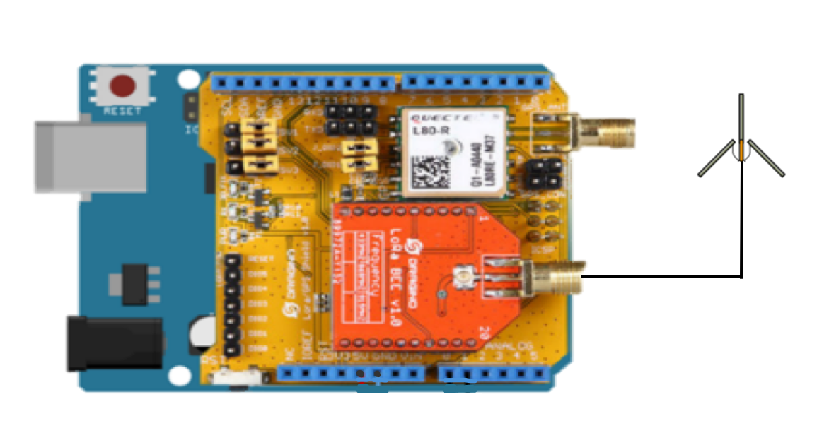

APRS

Arduino Uno and HX1 chip was used to transmit APRS packets at 144.390MHz, as shown in Fig. 5. Since the lack of a radio shield for APRS, HX1 was directly controlled to send signals. The transmitter antenna was suitable for 144-148 MHz frequency, with 1.17 dBi gain. The output power of the transmit antenna measured by the spectrum analyzer was 24 dBm. 50-ohm cable (RG213 50 Ohm Coax Cable) was used to connect the antenna and the HX1 transmitter to reduce signal loss. To receive APRS data packets, USRP b200 and antennas were used for hardware as shown in Fig. 6, and GNU radio on Ubuntu environment. The receiver antenna had 6 dBi gain. Finally, APRS's EIRP was 25.17 dBm.

<APRS’s transmitter>

시계이(가) 표시된 사진

매우 높은 신뢰도로 생성된 설명

<APRS’s receiver>

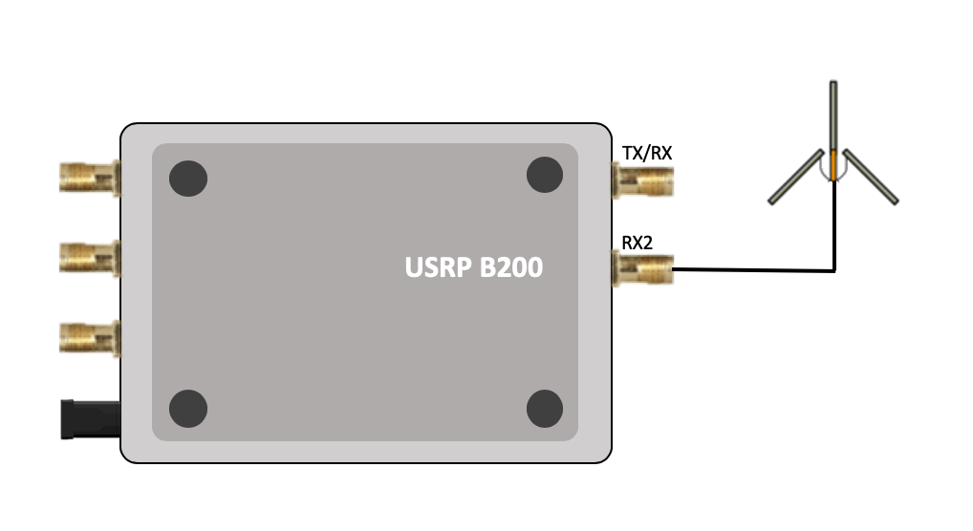

Test evaluation

With the antenna specifications that were used for the final test, the Friis transmission formula was used to review the final distance coverage results:

<equations>

“The Friis Transmission formula is a basic equation used to calculate the received power of a basic receiver at a fixed distance from a transmitting system.”\cite{b18}

According to the Friis Transmission formula, theoretically, APRS should have covered a longer distance than LoRa, as shown in Table 5. However, according to the final results, APRS distance was much shorter than LoRa. To understand the reasoning of the final test results, the Fresnel Zone Radius was calculated.

The definition of Fresnel Zone is the size of the elliptically-shaped area of RF propagation between a transmit and receive antenna.

“Objects within the area of the Fresnel zone can reflect radio waves and induce multi-path propagation issues between the transmitter and receiver, where direct path line-of-sight radio waves and the reflected path radio waves are received out of phase from one another.” \cite{b19}

Therefore, to have no interference, it is important to have no obstacles in the Fresnel Zone. This zone could be calculated by a Fresnel Zone Calculator:

<equations>

The antennas must be located within the 80\% of the radius obtained through the Fresnel zone theory, shown in Table 5, for seamless communication. \cite{b20}

The result of the Fresnel zone radius indicated that to communicate around the theoretical 59.7 km, the theoretical distance, away using APRS, the antennas for both transceiver and receiver antenna must be at least 140m above the ground. However, the antennas for testing were installed within 6.4m above the ground.

Additionally, to calculate the efficiency constrained by height, the tested distance was divided by the theoretical distance. LoRa was 45.16\%, while APRS was 1.44\%, as shown in Table 5.

Conclusion

This study was proposed to determine whether LoRa or APRS is more feasible (or feasible) for the networking technology in smart farms. The location of the experiment for the distance coverage of both networks was at an university’s agronomy center. According to the test results, LoRa’s final distance coverage was 4.2 km, when the transmitter gain was 9 dBi and the receiver gain was 6 dBi. While APRS distance coverage was 0.84 km, with 1.17 dBi of transmitter gain and 6 dBi of receiver gain.

The efficiency constrained by height from the final test results was 45.16\% for LoRa and 1.44\% for APRS.

<table>

Both of the estimated antenna installation heights calculated from the Fresnel Zone Radius are high altitudes, which the majority of the smart farm system cannot meet the circumstances. When comparing the installation possibility of the two networking technologies, LoRa’s theoretical distance was more achievable than APRS. Therefore, the result indicates that LoRa is more feasible than APRS for the networking technology in smart farms.

However, there are limitations to our test experiment. First, the antenna specification and the transmit power were different for LoRa and APRS. We tried to make LoRa's EIRP and APRS' EIRP the same, but the antenna gain and transmission power of LoRa and APRS were different. Second, the testing was done after the corns were all harvested. Hence, there could be different results when there are obstacles between the transmitter and receiver antennas.

Future tests will be performed by ensuring that LoRa and APRS have the same antenna gain and transmission power. Furthermore, the transmitter and receiver antennas will be installed at much higher altitudes.

References

1. M. S. Farooq, S. Riaz, A. Abid, K. Abid and M. A. Naeem, ``A Survey on the Role of IoT in Agriculture for the Implementation of Smart Farming,'' in IEEE Access, vol. 7, pp. 156237-156271, 2019.
2. “Cellular networks for Massive IoT: White paper,” Ericsson.com. [Online]. Available: https://www.ericsson.com/en/reports-and-papers/white-papers/cellular-networks-for-massive-iot--enabling-low-power-wide-area-applications. [Accessed: 17-Dec-2019].
3. M. Centenaro, L. Vangelista, A. Zanella and M. Zorzi, ``Long-range communications in unlicensed bands: the rising stars in the IoT and smart city scenarios,'' in IEEE Wireless Communications, vol. 23, no. 5, pp. 60-67, October 2016.
4. D. Patel and M. Won, ``Experimental Study on Low Power Wide Area Networks (LPWAN) for Mobile Internet of Things,'' 2017 IEEE 85th Vehicular Technology Conference (VTC Spring), Sydney, NSW, 2017, pp. 1-5.
5. K. Mekki, E. Bajic, F. Chaxel, and F. Meyer, “A comparative study of LPWAN technologies for large-scale IoT deployment,” ICT Express,vol. 5, no. 1, pp.1-7, 2019.
6. M. Ji, J. Yoon, J. Choo, M. Jang and A. Smith, ``LoRa-based Visual Monitoring Scheme for Agriculture IoT,'' 2019 IEEE Sensors Applications Symposium (SAS), Sophia Antipolis, France, 2019, pp. 1-6.
7. R. K. Kodali, M. S. Kuthada and Y. K. Yogi Borra, ``LoRa Based Smart Irrigation System,'' 2018 4th International Conference on Computing Communication and Automation (ICCCA), Greater Noida, India, 2018, pp. 1-5.
8. N. Hongyim and S. Mithata, ``Designing and Implementation Exploration Vehicle Remote Controller Using APRS Protocol,'' 2017 21st International Computer Science and Engineering Conference (ICSEC), Bangkok, 017, pp. 1-5.
9. K. Hajdarevic, S. Konjicija and A. Subasi, ``A low energy APRS-IS client-server infrastructure implementation using Raspberry Pi,'' 2014 22nd Telecommunications Forum Telfor (TELFOR), Belgrade, 2014, pp. 296-299.
10. The APRS Working Group, “APRS PROTOCOL REFERENCE,” 2000 APRS Working Group, Aug. 29, 2000. [Online]. Available: ftp://ftp.tapr.org/aprssig/aprsspec/spec/aprs101/APRS101.pdf. [Accessed: 14-Dec-2019].
11. “Friis Transmission Calculator,” Friis Transmission Calculator | Southwest Antennas - High Performance RF and Microwave Antennas & Custom Antenna Manufacturing. [Online]. Available: https://www.southwestantennas.com/calculator/friis-transmission. [Accessed: 15-Dec-2019].
12. “Fresnel Zone Calculator,” Fresnel Zone Calculator | Southwest Antennas - High Performance RF and Microwave Antennas & Custom Antenna Manufacturing. [Online]. Available: https://www.southwestantennas.com/calculator/fresnel-zone. [Accessed: 15-Dec-2019].
13. “Fresnel Zones – What are they and why are they so important?,” DigitalAir Wireless. [Online]. Available: https://www.digitalairwireless.com/articles/blog/fresnel-zones-what-are-they-and-why-are-they-so-important. [Accessed: 15-Dec-2019].